PIZZA SALES SQL QUERIES
- KPI
- Total Revenue
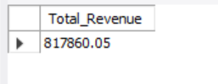
SELECT SUM(total_price) AS Total_Revenue FROM pizza_sales;

- Average Order Value
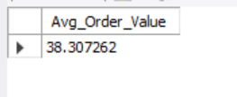
SELECT SUM(total_price) / COUNT(DISTINCT order_id) AS Avg_Order_Value FROM pizza_sales;

- Total Pizza Sold
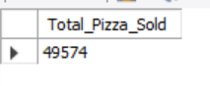
SELECT SUM(quantity) AS Total_Pizza_Sold FROM pizza_sales;

- Total Orders
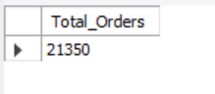
SELECT COUNT(DISTINCT order_id) AS Total_Orders FROM pizza_sales;

- Average Pizzas Per Order
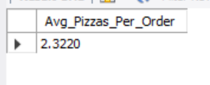
SELECT SUM(quantity) / COUNT(DISTINCT order_id) AS Avg_Pizzas_Per_Order FROM pizza_sales;

- CHARTS
- Daily Trend for Total Order
SELECT DAYNAME(order_datetime) AS Order_Day, COUNT(DISTINCT order_id) AS Total_Orders
FROM pizza_sales
GROUP BY DAYNAME(order_datetime)
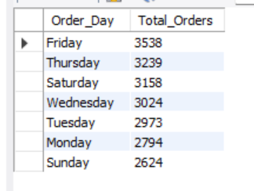
ORDER BY COUNT(DISTINCT order_id)DESC;

- Monthly Trend for Total Orders
SELECT
MONTH(order_datetime) AS Month_No,
MONTHNAME(order_datetime) AS Month_Name,
COUNT(DISTINCT order_id) AS Total_Orders
FROM pizza_sales
GROUP BY Month_No, Month_Name
ORDER BY Total_Orders DESC;

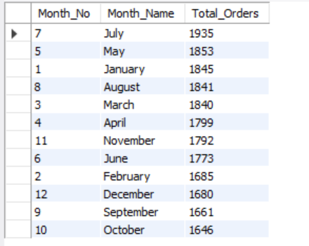
- Hourly Trend for Total Orders
SELECT
HOUR(order_datetime) AS Order_Hour,
COUNT(DISTINCT order_id) AS Total_Order
FROM pizza_sales
GROUP BY Order_Hour
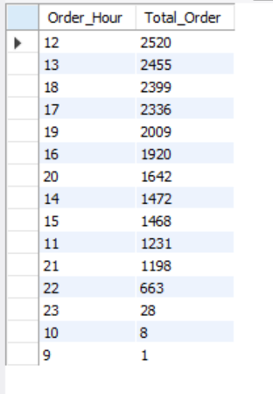
ORDER BY Total_Order DESC

- Percentage of Sales by Pizza Category
SELECT
pizza_category,
SUM(total_price),
ROUND(SUM(total_price) * 100 /
(SELECT SUM(total_price) FROM pizza_sales), 2) AS Sales_Percentage
FROM pizza_sales
GROUP BY pizza_category
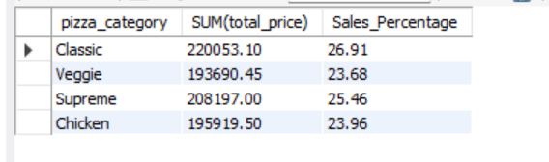

- Percentage of Sales by Pizza Size
SELECT
pizza_size,
SUM(total_price),
ROUND(SUM(total_price) * 100 /
(SELECT SUM(total_price) FROM pizza_sales), 2) AS Sales_Percentage
FROM pizza_sales
GROUP BY pizza_size
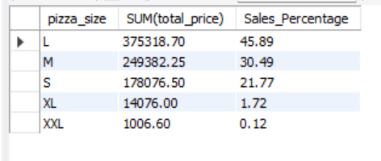
ORDER BY Sales_Percentage DESC

- Top 5 Best Sellers by Revenue
SELECT
pizza_name,
SUM(total_price) AS Total_Revenue
FROM pizza_sales
GROUP BY pizza_name
ORDER BY Total_Revenue DESC
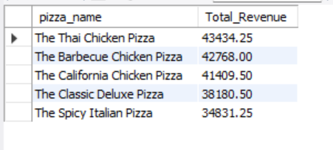
LIMIT 5

- Bottom 5 Best Sellers by Revenue
SELECT
pizza_name,
SUM(total_price) AS Total_Revenue
FROM pizza_sales
GROUP BY pizza_name
ORDER BY Total_Revenue ASC
LIMIT 5

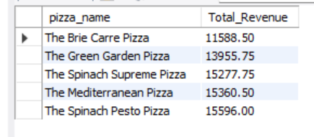

- Top 5 Best Sellers by Quantity
SELECT
pizza_name,
SUM(quantity) AS Total_Quantity
FROM pizza_sales
GROUP BY pizza_name
ORDER BY Total_Quantity DESC
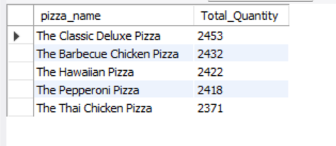
LIMIT 5

- Bottom 5 Best Sellers by Quantity
SELECT
pizza_name,
SUM(quantity) AS Total_Quantity
FROM pizza_sales
GROUP BY pizza_name
ORDER BY Total_Quantity ASC
LIMIT 5
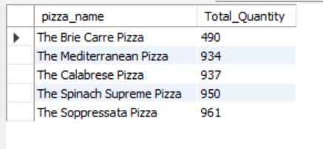

- Top 5 Best Sellers by Orders
SELECT
pizza_name,
COUNT(DISTINCT order_id) AS Total_Order
FROM pizza_sales
GROUP BY pizza_name
ORDER BY Total_Order DESC
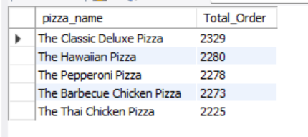
LIMIT 5

- Bottom 5 Best Sellers by Orders
SELECT
pizza_name,
COUNT(DISTINCT order_id) AS Total_Order
FROM pizza_sales
GROUP BY pizza_name
ORDER BY Total_Order ASC
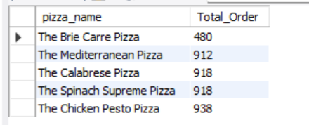
LIMIT 5

